Thank You

DR. (insert name)
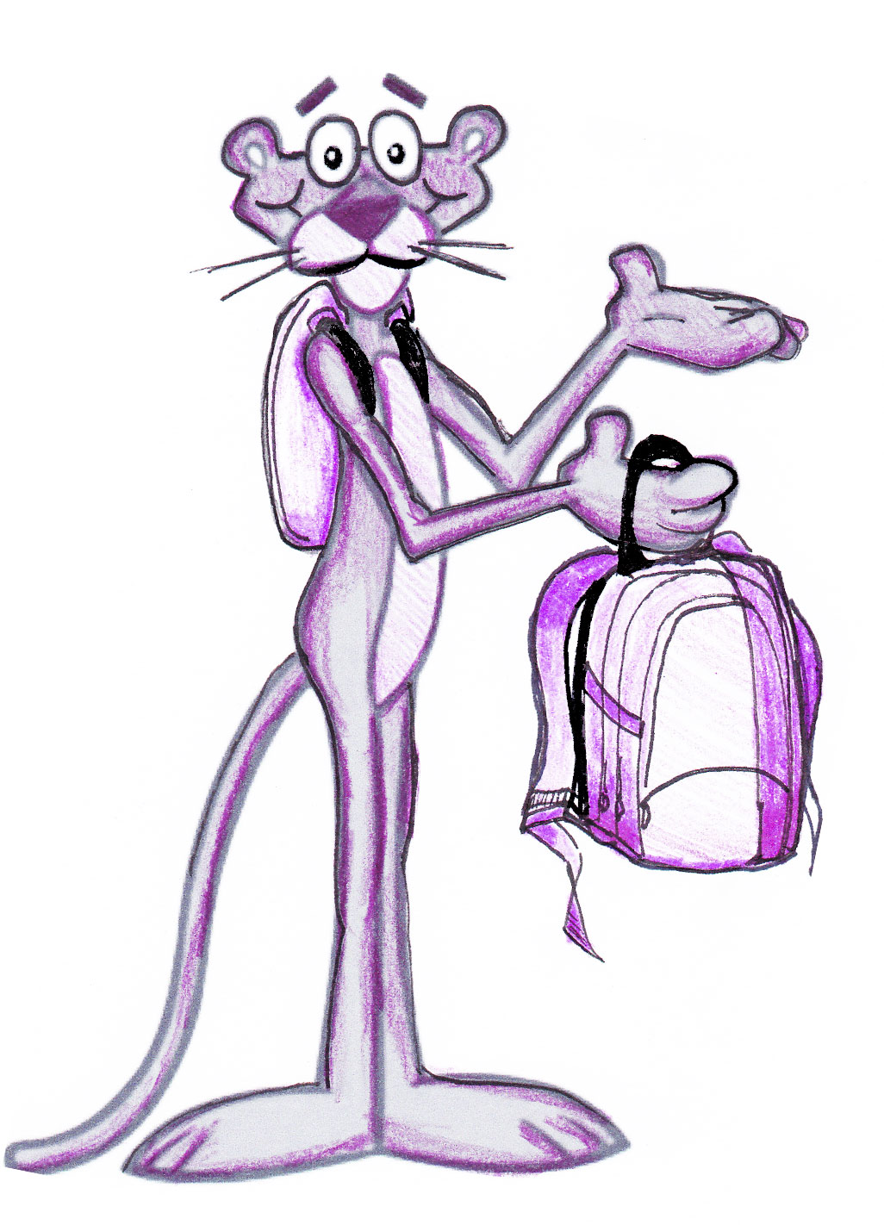

For donating our Backpack Raffle Prize

(donator’s url here)

